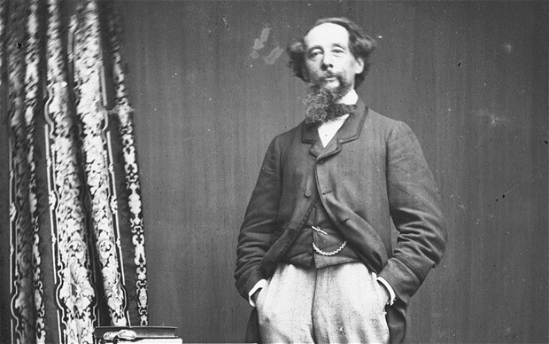
Adapting Dickens
A one-day conference
De Montfort University
Leicester
27 February 2013

The Centre for Adaptations and the Association of Adaptation Studies will be hosting a one-day conference at De Montfort University, Leicester, on Wednesday the 27th February 2013. Among the speakers are Andrew Davies (prolific writer and screenwriter whose recent Dickens adaptations include Bleak House and Little Dorrit) and Michael Eaton (among his many projects are adaptations of Dickens for BBC Radio Four and the Arena documentary, ‘Dickens and Film’).

The conference includes papers on adaptations of Dickens by scholars from all over the world, including film noir Dickens, loose adaptations, Dickens and The Dark Knight Rises, and national, political and cultural adaptations of Dickens. For further information, contact
djc@dmu.ac.uk Conference Fee: £50.00 (£30.00 concessions)
Booking is available at:

http://store.dmu.ac.uk/browse/product.asp?catid=74&modid=1&compid=1
